Mounties Summer Reading Newsletter

Upcoming Summer Events

JUNE~JULY~AUGUST
*Check out the Summer Reading Blog on Mounties Webpage regularly
- Summer Reading Challenge – 600 minute goal

- Door prizes being given away at all events

- Summer AR Points/Quizzes

- Library nights: Tuesdays;
June 30th 6:00-7:00 pm, July 28th
7:00-8:00 pm,
August 18th
6:00-7:00 pm

- July Event
Movie night-RRR football field
July 28th, 8pm-?

- Award and final prize given to all who read 600mins

Be a Mountie Reader this summer!

It is easy, this is how.

Wouldn’t it be wonderful if every Central reader participated in our summer reading events? As a result, all readers would not experience the grueling summer slide and be ready readers for next school year! Also, all would have the chance to win prizes!
We, at Central, are committed to offer various summer literacy events to keep our students reading over the summer months. Reading achievement declines an average of three months between June and September when children do not read over the summer months.
Therefore, this summer brings many summer reading opportunities to promote reading. James V. Brown’s Summer Reading Program, “ begins June 25-August 6.

.
On top of the James V. Brown Library program, we at SOUTH are challenging every student to read a goal of 600 minutes!
You may wonder, “Where will I get books for my child?” The open library nights are the perfect chance for your child to sign out books and mingle with friends and faculty.
Through our Summer Reading Survey, we learned that community literacy events are important to you and we have made it a point to offer more this summer. In July, we are having a Movie night and book swap on the practice field. Bring gently used books to swap for another book. Max of 3 books a piece. We will be playing the movie on the RRR building wall.


Summer Reading Challenge
- All students are challenged to read daily to meet the 600 goal over the summer
- Read 20 minutes a day or do your best to READ,READ,READ
- Track your minutes by coloring in a box on the reading log
- Return your summer reading log by Friday, September 4, 2015
- All participants who read 600 minutes will receive a summer reading certificate, special incentive, and chances to win grand prizes! Also, No Summer slide!

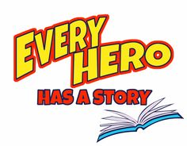


Central Open Library Nights!

- Central Library will open several Tuesdays this summer for an evening of signing out books, taking AR quizzes and visiting friends and teachers.
- Tuesdays; June 30th 6:00-7:00 pm, July 28th 7:00-8:00 pm, August 18th from 6:00-7:00 pm
- Tuesday, June 30th is Registration night for James V. Brown Library’s Summer Reading Program at Central Library
- Door prizes given away at each library night

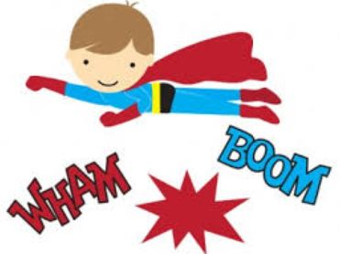



- Come sit back and enjoy an evening of popcorn and a movie.
- Bring blankets, books to swap, and the family for some fresh air.
- July 28th 8pm-? at Rommelt practice field

