#### APUSH 2015-16 **COURSE DESCRIPTION: Mr. Radulski** [smradulski@swasd.org](mailto:smradulski@swasd.org)

**Keys to Success:**

**The most important factor affecting your grade is consistent effort. This will link directly to the grades you earn for assignments and for participation grade. The reading load will take adjusting to in the first several weeks. Sharing of knowledge and forming study groups is encouraged. Plagiarism is not acceptable. You should expect to do something for this class every day or night.**

#### The study of history is not just the arranging of facts in chronological order. It is delving into events to understand the multiple perspectives surrounding popular beliefs and ideas about those events. The hope is that you emerge from this course with an appreciation and pleasure in learning beyond memorization, a wide scope of knowledge of US history, a feeling of preparedness for taking the AP exam, and the acquisition of skills useful for both history and other classes.

#### The ultimate goal of this course is to develop students who look beyond the simple answer. The areas of concentration include historical, political and economic history coupled with the study of cultural and intellectual institutions and their development. These areas will be studied from a variety of perspectives with the hope of providing a balanced view of history. This course will require a large amount of reading and depth of focus of material, as well as keeping up with the swift pace of the class. Moreover, the AP curriculum stresses higher order thinking skills within a rigorous academic context. Thus, the student will be required frequently to analyze, synthesize, and evaluate primary and secondary historical sources in addition to memorizing, comprehending, and applying facts. The course is divided into two semesters, Native Americans & Contact through Manifest Destiny, Civil War and Reconstruction and The Gilded Age of Industrial, Urban and Political Transformation to the Conservative America in the Ascent*.* The objective of this course is to increase the student's understanding of United States history with the goal of having each student pass the AP Examination.

**OBJECTIVES:**

1. **Master a broad body of knowledge**
2. **Demonstrate an understanding of historical chronology**
3. **Use historical date to support an argument or position**
4. **Differentiate between different schools of historical thought**
5. **Interpret and apply date from original documents, including speeches, cartoons, graphs, letters, works of art, music lyrics and others**
6. **Use the analytical skills of evaluation, cause and effect, compare and contrast**
7. **Work with others to produce a variety of products to benefit the learning of others**
8. **Prepare for and successfully pass the AP exam**

**The issued text is:**

**Henretta, James A et al. *America’s History* (8/e). Boston: Bedford/St. Martin’s, 2014**

**Supplementary Texts:**

1. **Newman, John J. and John M. Schmalbach. *United States History: Preparing for the Advanced Placement Examination (Revised Edition).* New York: AMSCO School Publications, Inc. 2006**
2. **Kennedy, David M. and Thomas Bailey. *The American Spirit (10th edition).* Boston: Houghton Mifflin Company. 2002.**
3. **Oates, Stephen B. ed. *Portrait of America*.7th ed. 2 vols. Boston: Houghton Mifflin Company. 1999**
4. Kunhardt Jr., Phillip, et. al., The American President. New York: Riverhead Books, 1999
5. **Madaras, Larry and James M. SoRelle. *Taking Sides. Clashing Views on Controversial Issues in American History*. 5th ed. 2 Vols. Guilford, CT: The Dushkin Publishing Group, Inc. 1993.**

**You are welcome to purchase your own review book – Kaplan and Crash Course are two options.**

**ONLINE VIDEOS:**

1. **APUSHREVEW.com These directly relate to each of the chapters. They are about 15 minutes long each. Very helpful for overview!** <http://www.apushreview.com/textbook-chapter-review-videos-2/chapter-review-videos/>

1. <http://ap.gilderlehrman.org/> **APUSH Eras in ten minutes. Watch the first and second one for an overview of the time periods you’ll see over the summer and at the beginning of the year.**

### **Assignments**

1. **Students are responsible for completing reading assignments and distributed questions. Unit assignment sheets will initially be given to students every two to three weeks.**
2. **Quizzes will be given routinely to test content familiarity. Do your readings and notes!**
3. **Unit exams will be given every two to three weeks at the conclusion of each unit.**
4. **Essay exams will be given approximately once every 6 weeks, usually combining 2 units.**
5. **Class will be a combination of student activities and discussion, lecture, cooperative learning and special projects.**

**Class Absence.** School policy states you have the same number of days missed to make up your work. Being absent the day of the test/quiz requires you make up within 2 days. The same applies for notes or assignments due. Exams and quizzes will be made up during study hall or after school. Make up tests will NOT be given in class. Being absent for a graded debate or activity will result in you having to submit a paper of 500-750 words in lieu **of the debate, and due within 3 days of the assignment due date. Work is due on the due date. Late assignments will be reduced in grade by 10% each day, up to a maximum of 30%. Work is not accepted more than three days after the due date.**

#### Academic Integrity: You are expected to share and discuss information and content with others. However, unless specifically allowed, all work for the class is expected to be your own. Copying, plagiarizing and taking credit for work that is not your own will result in a zero for the assignment and a phone call to your parents.

#### CLASS RULES

#### I want you to do well. Please see me if you have any concerns or questions. However, be aware that I cannot give you my undivided attention during class. See me after school for any additional assistance, and do so in a timely manner if a project or paper is concerned.

#### BASICS: Treat others kindly, try your hardest, ask questions and SPEAK UP!

#### Always give your best effort in class and on all assignments. They are opportunities to learn, achieve and grow.

#### Academic Freedom. All students have a right to their historical interpretations and opinions. How you SUPPORT them is key to doing well in class and on the AP exam. RESPECT for others is required.

#### Remember, while you are encouraged to study together and help each other, you are expected to do your own work at all times for individually graded assignments such as essays. Plagiarism is not acceptable. It will result in a zero for the assignment.

#### ADDITIONAL INFORMATION

#### Currently, I plan to pull APUSH students into class early, 2 to 3 times per week, taking them out of their study halls in order to increase APUSH instructional time. This will depend on student schedules as well.

**FAMILY EDUCATION RIGHTS & PRIVACY ACT (FERPA)**

Please know that ongoing critical evaluation by peers, which may include exchanging drafts of papers, will be used to enhance the educational process. Final assessment of student work is my job as the teacher. Student privacy will be respected when providing all confidential information.

**LASTLY…**Be positive! The course will be challenging, especially the first few units, until you get used to the course load and the requirements. You can do it!

**Scope and Sequence of the Course**

1. Unit 1: AP Period 1 1491-1607 (7 days) 1450-1600

**Period 1: 1491-1607: Native Americans & Contact** On a North American continent controlled by American Indians, contact among the peoples of Europe, the Americas, and West Africa created a new world.

* + Summer Assignments due within first three days of school starting
  + Ch. 1 Colliding Worlds 1450-1600
  + Ch. 2 American Experiments 1521-1700

1. Unit 2: AP Period 2 1607-1754 (2-1/2 weeks/13 days) 1607-1763

**Period 2: 1607-1754: Colonization** Europeans and American Indians maneuvered and fought fordominance, control, and security in North America, and distinctive colonial and native societies emerged.

* + Ch. 3 The British Atlantic World 1660-1750
  + Ch. 4 Growth, Diversity and Conflict 1720-1763

1. Unit 3a: AP Period 3 (a) 1754-1800 (2 weeks/10 days) 1763-1789

**Period 3: 1754-1800: Independence & Birth of a Nation**British imperial attempts to reassert control over its colonies and the colonial reaction to these attempts produced a new American republic, along with struggles over the new nation’s social, political, and economic identity

* + Ch. 5 The Problem of Empire 1763-1776
  + Ch. 6 Making War and Republican Governments 1776-1789

1. Unit 3b: AP Period 3 (b) 1754-1800 (2 weeks/10 days) 1787-1820
   * Ch. 7 Hammering Out a Federal Republic 1787-1820
   * Ch. 8 Creating a Republican Culture 1790-1820

***End 1st Marking Period***

1. Unit 4a: AP Period 4 (a) 1800-1848 (2 weeks/10 days) 1800-1844/60

**Period 4: 1800-1848: Jeffersonian & Jacksonian Eras** The new republic struggled to define and extend democratic ideals in the face of rapid economic, territorial, and demographic changes

* + Ch. 9 Transforming the Economy 1800-1860
  + Ch. 10 A Democratic Revolution 1800-1844

1. Unit 4b: AP Period 4 (b) 1800-1848 (2 weeks/10 days) 1800-1860
   * Ch. 11 Religion and Reform 1800-1860
   * Ch. 12 The South Expands: Slavery and Society 1800-1860
2. Unit 5a: AP Period 5 (a) 1844-1877 (2 weeks/10 days) 1844-1865

**Period 5: 1844-1877: Manifest Destiny, Civil War and Reconstruction** As the nation expanded and its population grew, regional tensions, especially over slavery, led to a civil war — the course and aftermath of which transformed American society.

* + Ch. 13 Expansion, War and Sectional Crisis 1844-1860
  + Ch. 14 Two Societies at War 1861-1865

**Winter Holiday Break**

1. Unit 5b: AP Period 5 (b) (2 weeks/10 days) 1865-1877/90
   * Ch. 15 Reconstruction 1865-1877
   * Ch. 16 Conquering a Continent 1854-1890

***End 2nd Marking Period***

1. Unit 6a: AP Period 6 (a) 1865-1898 (2 weeks/10 days) 1877-1917

**Period 6: 1865-1898:The Gilded Age of Industrial, Urban and Political Transformation** The transformation of the United States from an agricultural to an increasingly industrialized and urbanized society brought about significant economic, political, diplomatic, social, environmental, and cultural changes

* + Ch. 17 Industrial America: Corporations and Conflicts 1877-1911
  + Ch. 18 The Victorians Make the Modern 1880-1917

1. Unit 6b: AP Period 6 (b) (2 weeks/10 days) 1880-1917
   * Ch. 19 “Civilization’s Inferno”: The Rise and Reform of Industrial Cities 1880-1917
   * Ch. 20 Whose Government? Politics, Populists and Progressives 1880-1917
2. Unit 7a: AP Period 7 (a) 1890-1945 (2 weeks/10 days) 1890-1932

**Period 7: 1890-1945: Imperialism, Wars and Depression**

An increasingly pluralistic United States faced profound domestic and global challenges, debated the proper degree of government activism, and sought to define its international role.

* + Ch. 21 An Emerging World Power 1890-1918
  + Ch. 22 Cultural Conflict, Bubble and Bust 1919-1932

1. Unit 7b: AP Period 7 (b) (2 weeks/10 days) 1929-1945
   * Ch. 23 Managing the Great Depression, Forging the New Deal 1929-1939
   * Ch. 24 The World at War 1937-1945

***End 3d Marking Period***

1. Unit 8a: AP Period 8 (a) 1945-1980 (2 weeks/10 days) 1945-1969

**Period 8: 1945-1980:The Cold War**  After World War II, the United States grappled with prosperity and unfamiliar international responsibilities, while struggling to live up to its ideals.

* + Ch. 25 Cold War America 1945-1963
  + Ch. 26 Triumph of the Middle Class 1945-1963

1. Unit 8b: AP Period 8 (b) (3 weeks/15 days) 1950s-1980
   * Ch. 27 Walking into Freedom Land: The Civil Rights Movement 1941-1973
   * Ch. 28 Uncivil Wars: Liberal Crisis and Conservative Rebirth
   * Ch. 29
2. Unit 9: AP Period 9 (2 weeks/10 days) 1980-presentCh. 30
3. **Period 9: 1980-Present: Conservative America in the Ascent,** 1980-91. As the United States transitioned to a new century filled withchallenges and possibilities, it experienced renewed ideological and cultural debates, sought to redefine its foreign policy, and adapted to economic globalization and revolutionary changes in science and technology
   * Ch. 30 Conservative America in the Ascent
   * Ch. 31 Confronting Global and National Dilemmas, 1989 – now.

***End 4th Marking Period***

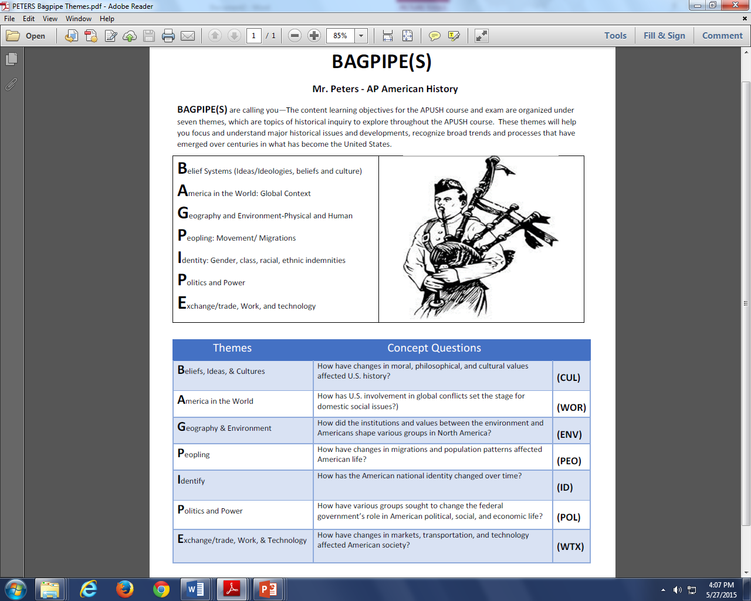

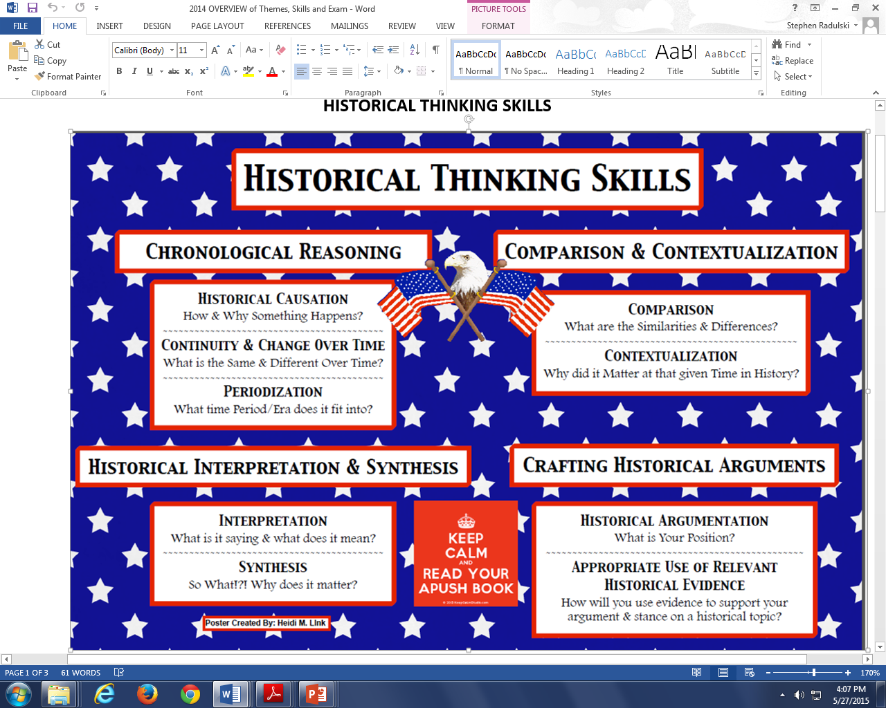

**Summer Assignment:**

1. Watch the videos (Chapter 1 and 2 from the APUSHReview.com site) and the Era 1 video (<http://ap.gilderlehrman.org/>**)**
2. **Read and take notes on Chapters 1 and 2** using the notesheets provided. Please complete all notes in BLUE or BLACK INK, not pencil.
   1. Target date to complete Chapter 1: August 7th, 2015
   2. Target date to complete Chapter 2: August 14th, 2015
3. **Read AMSCO, Chapters 1 and 2.**
4. **Complete the “Reaction Paper” assignment**. Target date for completion August 21st, 2015.
5. Additional Handouts
   1. APUSH REVIEW REFERENCES – overview of exam and the NINE (9) eras.
   2. SPARKNOTES US HISTORY TIMELINE 1492-1865 & 1865-2004
6. Review the two maps provided.

All assignments are due on the first day of school. Anticipate quizzes on Chapters 1 and 2 in the first few days of school in the fall.

Notesheets will be available online in word format by July.

You need a three ring binder for class with loose leaf paper. A 1-1/2” binder to start is sufficient. Buy a few of them to start.

Leave the AMSCO and textbook at home – I have extras at school for in-school use.

Contact me via email with any questions.

**Advanced Placement United States History (APUSH) Preparatory Assignment DUE JUN 4th, 2015**

I, (parent name)__________________________________________, hereby acknowledge and agree that (student name)___________________________________________ will complete the preparatory requirements for APUSH prior to the start of the **2015-2016 Academic School Year (ASY).**

All academic requirements will be counted towards the student’s grade for the first marking period of the 2015-16 ASY. Assignments due on the first day of the 2015-2016 ASY

Students who are not able to complete the requirements are welcome to remain in the class. No makeup assignments or extensions are allowed. They will earn no credit for the assignments.

Students are to return this signature sheet to Mr. Radulski, or have it placed in his mailbox in the office no later than June 4th, 2015. Failure to return this sheet will result in the recommendation that the student be dropped from the course.

Students requiring assistance during the summer months are to email Mr. Radulski at [sradulski@swasd.org](mailto:sradulski@swasd.org). Responses will be made with 72 hours.

**APUSH Summer 2015-16 Short List of Requirements:**

Textbook Numbers: America’s History:____________ AMSCO__________

1. Watch the videos (Chapter 1 and 2 from the APUSHReview.com site) and the Era 1 video (<http://ap.gilderlehrman.org/>**)**
2. Read and take notes on Chapters 1 and 2 using the notesheets provided. Please complete all notes in BLUE or BLACK INK, not pencil.
   1. Target date to complete Chapter 1: August 7th, 2015
   2. Target date to complete Chapter 2: August 14th, 2015
3. **Read AMSCO, Chapters 1 and 2.**
4. Complete the “Reaction Paper” assignment. Target date for completion August 21st, 2015.

All assignments are due on the first day of school.

Anticipate quizzes on Chapters 1 and 2 in the first few days of school in the fall.

**v/r SMR retain the top portion of this sheet.**

**APUSH 2015-16 Acknowledgement of Preparatory Assignment. DUE NLT June 4th, 2015.**

**Mr. Radulski.** 570-326-2684 x3223 [sradulski@swasd.org](mailto:sradulski@swasd.org)

Student Name: Print_______________________________________________

Student Signature:_________________________________________________

Parent/Guardian Name: Print _______________________________________

Parent/Guardian Signature:__________________________________________

Date:_____________________________________________________________